Q1)

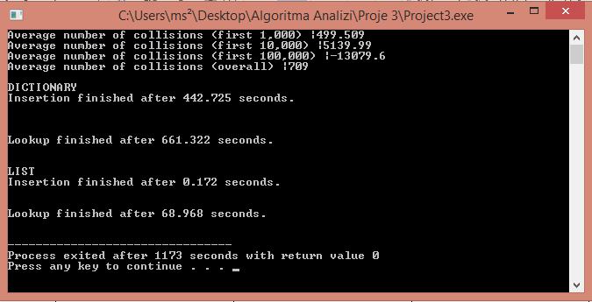

|  |  |  |
| --- | --- | --- |
| Second(s) | Dictionary | List |
| Insertion | 442.725 | 0.172 |
| Lookup | 661.322 | 68.968 |

I did not get the dictionary part properly because I left the homework last time. I did not understand why it is making so much collisions but because of that it is being so much time. It does so much collisions and gives the right result even though it takes a long time.

Q3)

It's getting harder to find free space because vacancies are constantly diminishing. Therefore average collisions are increasing exponentially.

Q4)

If there is always a maximum collisions it becomes n*(n+1) / 2 so O(n^2).